***PSEUDOCODE DAN FLOWCHART 4***

**ALGORITMA PEMOGRAMAN**



**RAFKI AHMAD PAGAMANDA**

**2311533016**

**DOSEN PENGAMPU: Dr. Wahyudi, S.T, M. T**

**JURUSAN INFORMATIKA**

**FAKULTAS TEKNOLOGI INFORMASI**

**UNIVERSITAS ANDALAS**

**TAHUN 2023/2024**

Nama: Rafki Ahmad Pagamanda

NIM : 2311533016

**Flowchart**

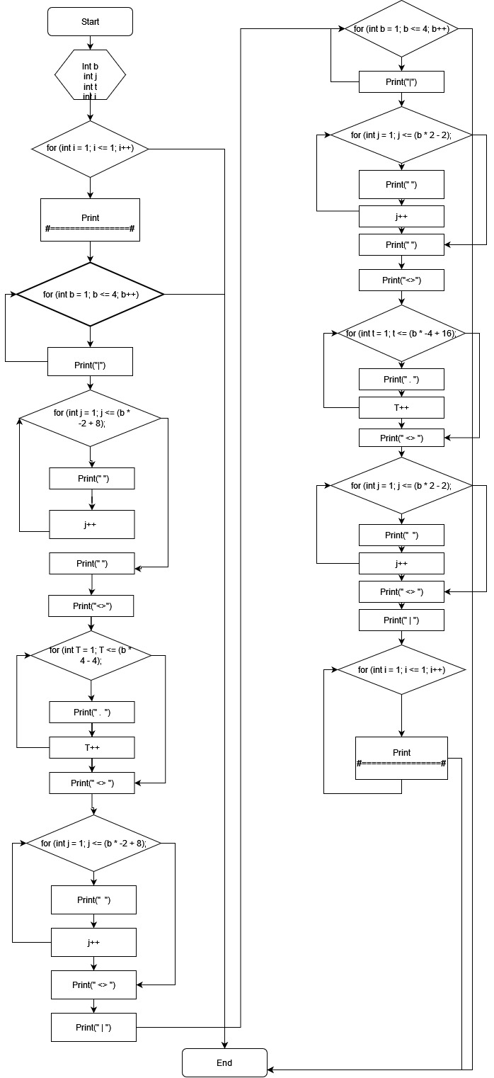

**Pseudocode**

for i = 1 to 1 do

output("#================#")

end for

for b = 1 to 4 do

output("|")

for j = 1 to (b * -2 + 8) do

output(" ")

end for

output("<>")

for T = 1 to (b * 4 - 4) do

output(".")

end for

output("<>")

for j = 1 to (b * -2 + 8) do

output(" ")

end for

output("|")

end for

for b = 1 to 4 do

output("|")

for j = 1 to (b * 2 - 2) do

output(" ")

end for

output("<>")

for t = 1 to (b * -4 + 16) do

output(".")

end for

output("<>")

for j = 1 to (b * 2 - 2) do

output(" ")

end for

output("|")

end for

for i = 1 to 1 do

output("#================#")

end for

end procedure